# *Lab 7 – Introduction to Financial Accounting*

Date assigned: Tuesday, April 12, 2016

Date due: **Friday, April 15, 2016, 9:00 a.m.**

**Learning Objectives**

Upon successful completion of this assignment, the student will be able to:

* Use the basic accounting equation
* Analyze balance sheets and income statements
* Calculate and compare financial ratio’s

To do:

Save this document as a Word document named **YourUserName_E01_L07_Accounting.docx** in your 420-E01 folderin your home drive. The document will hold your answers for your lab.

**This week the lab is split over 2 days. On each of Tuesday and Friday, there will be a 1 hour portion provided for this lab. Questions 1 – 4 should be completed on Tuesday, and questions 5 -8 should be completed on Friday.**

1. Determine the missing amount for each of the following equations: **(3 marks)**

|  |  |  |
| --- | --- | --- |
| Assets = Liabilities + Owner’s Equity | | |
| 1. $75,000 | $40,500 | $34,500 |
| 1. $300,000 | $214,500 | $85,500 |
| 1. $282,900 | $187,500 | $95,400 |

1. For each item, state which financial statement or statements (Income, Balance or Neither) it should be presented on. **(8 marks)**
2. Office Supplies

* Balance

1. Office Supplies expense

* Balance

1. Accounts receivable

* Income

1. Accounts payable

* Balance

1. Net loss

* Balance

1. Office equipment

* Neither

1. Owner, withdrawals

* Balance

1. Notes payable

* Balance

1. Utilities expense

* Balance

1. Furniture

* Neither

1. Rent revenue

* Balance

1. Consulting fees earned

* Income

1. Service fees earned

* Income

1. Salaries expense

* Balance

1. Owner, investments

* Income

1. Net income

* Income

1. State which part of the balance sheet (Asset, Liability, Owner’s Equity, Does not appear on balance sheet) each item should be presented on. **(5 marks)**
2. Net loss

* assets

1. Office supplies

* assets

1. Accounts payable

* liability

1. Accounts receivable

* assets

1. Owner’s investment

* equity

1. Furniture

* assets

1. Net income

* equity

1. Notes payable

* Liability

1. Owner’s withdrawals

* equity

1. Truck

* assets

1. On November 1, 2014, Joseph Grayson organized a new consulting firm called The Grayson Group. On November 30, 2014, the company’s records showed the following items.

|  |  |
| --- | --- |
| Cash……………………………………..$12,000  Accounts receivable……………..$15,000  Office supplies……………………….$2,250  Cars……………………………………….$36,000  Office Equipment…………………..$28,000  Accounts payable………………….$7,500  Owner’s investments…………….$84,000 | Owner’s withdrawals…………………….$3,360  Consulting fees earned………………..$15,000  Rent expense………………………………..$2,550  Salaries expense……………………………$6,000  Telephone expense………………………..$660  Utilities expense…………………………….$680 |

1. Use this information to prepare a November 30 balance sheet for The Grayson Group. Prepare the balance sheet in Excel, and then paste it into this document. Use formula’s to calculate any mathematical operations needed. **(10 marks)**

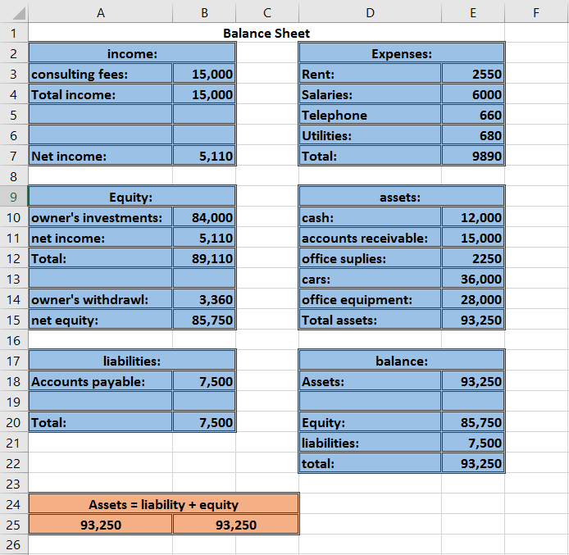

1. With all other factors constant, indicate whether each of the following changes generally signals good or bad news about a company: **(8 marks)**
2. Increase in net profit margin

* Good

1. Decrease in inventory turnover

* Bad

1. Increase in current ratio

* Bad

1. Decrease in earnings per share

* Bad

1. Increase in price-earnings ratio

* Good

1. Decrease in quick ratio

* Bad

1. Increase in debt ratio

* Bad

1. Decrease in long term debt to equity

* Good

1. The following information is from the Dec. 31, 2014, balance sheet of Paff Corp:

Cash - $820,000

Accounts receivable - $240,000

Inventories - $470,000

Capital assets - $910,000

Accounts payable - $350,000

Income taxes payable - $180,000

Cost of goods sold - $750,000

Calculate the following: **(6 marks)**

1. Current ratio

Current assets / Current liabilities

(820,000 + 240,000 + 910,000 + 470,000) / (350,000 + 180,000)

=4.6

1. Acid-test ratio

Current assets – Inventory / current liabilities

(820,000 + 240,000 + 910,000) / (350,000 + 180,000)

=3.7

1. Inventory turnover ratio

Cost of goods sold / Average inventory

750,000 / 470,000

=1.59

1. Find out the price-earnings ratio (PE ratio) of Facebook, Amazon and Alphabet(Google). Based on the PE ratios, which company should investors favour? Explain your answer. **(4 marks)**

Facebook: 87.55%

Amazon: 506.39%

Alphabet: 33.02%

Owners should invest in Alphabet because their PE ratio is low meaning that the cost of their shares is almost balanced out by the amount earned by that share.

1. A firm has a Return on Equity (ROE) of 20%. The industry average ROE is 12%. Is this a good or poor sign about the management of the firm? **(4 marks)**

This is a bad sign because the company costs almost twice as much as the market average so investors won’t want to invest in it as much.

**To submit**

When you have completed the assignment, upload the **YourUserName_E01_L07_Accounting.docx** document to Moodle.